The story of the two Covenanters’ Flags of Cumnock Parish

Bobby Guthrie recently contacted Cumnock History Group regarding the tale of two covenanters’ flags of the Parish of Cumnock.

“When I presented my re-discovery of the 'second' Cumnock Covenanting Flag to New Cumnock History club 10 years ago, I quoted the work of the Rev John Warrick in his History of Old Cumnock who simply observed that there was another Cumnock Covenanter flag "almost similar" to that one now to be found in the Baird institute. However, on visiting the Hunterian many years ago I found the fragment of flag to be part of a saltire which had all the hallmarks of the regimental banners used during the Civil War of the Three Kingdoms. The name CVMNOK appears at the centre of the saltire and I wondered if it was flown by the company of men from Cumnock parish (pre-division of the parish) that were in the Kyle and Carrick Regiment of Foot (comprised 10 companies) who fought at Marston Moor in 1644 and were badly mauled at Alford the following year.

Having just found a newspaper clipping from the Glasgow Herald February 1898 with a letter from the bold Rev Warwick it is clear he had seen the flag at the Hunterian and although his History of Old Cumnock was published the following year, I guess time was not on his side to report his discovery. Mr Warrick attributes the name Cumnock on both the Baird Flag (Bothwell Brig 1679) and the Hunterian Flag to the town where it is more likely to be a reference to the name of the parish. Marston Moor pre-dates the division of the parish in 1650 and Bothwell followed after that division was annulled in 1667, certainly there would be as many tenant farmers at Bothwell than townsfolk!

Mr Warrick also attributes the provenance of the Baird flag to that of the Hunterian flag, ie found in the house of medical practitioner Dr Kirkland. However, in my discussions with the Hunterian their records show it was donated by Miss Mary Logan in 1819 (possibly a daughter of a graduate?). As yet I haven't been able to trace that family - so any suggestions would be welcomed. At the time I visited the museum the flag was hidden away in the archives and had suffered smoke damage from a fire in the museum many years ago. The Rev Warrick would have been lucky to witness the flag in its original colours. We hope with the help of EAC to create a replica to hang in our new Heritage Centre - and Cumnocks Old and New will have a flag apiece to recall a fascinating period of our history.”

Cumnock Covenanters Flag - Hunterian Museum, Glasgow

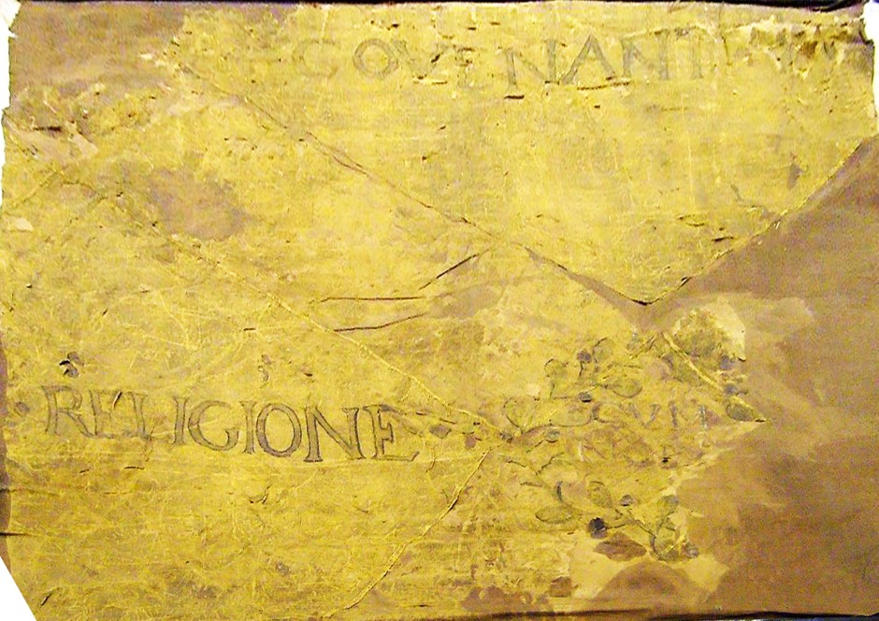

Covenanters banner: Cumnock; silk with fabric backing; gold thread.
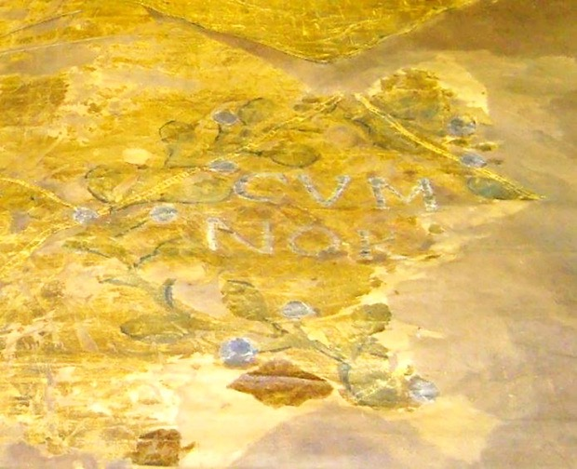

Covenanters Flag - Baird Institute, Cumnock

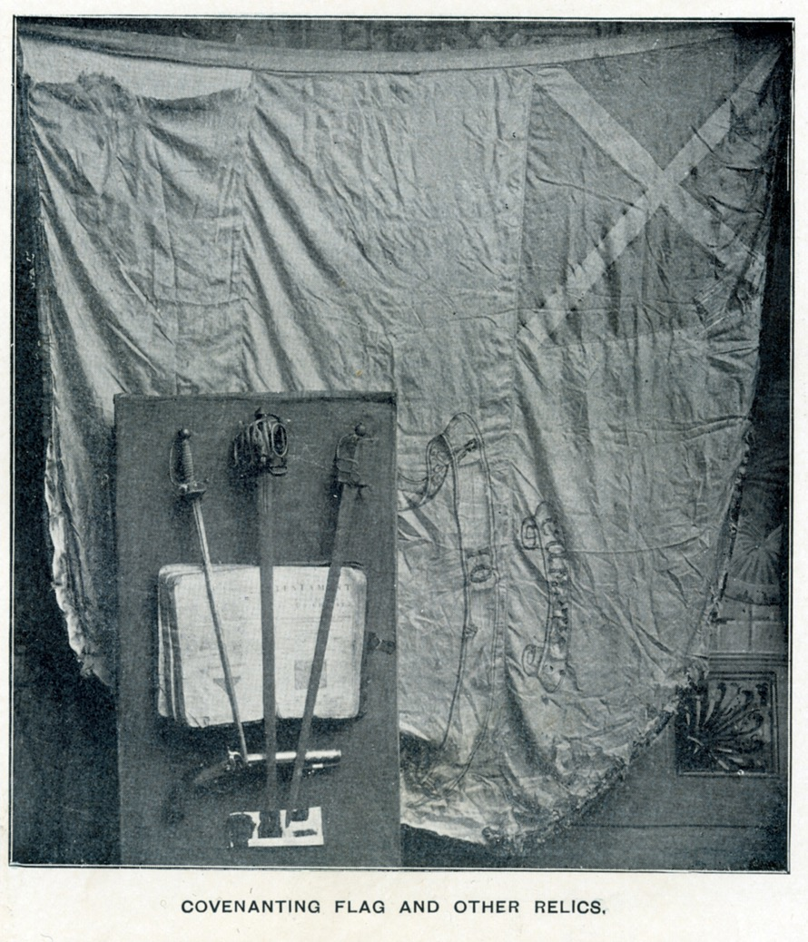

According to tradition this flag was carried at Drumclog in 1679 when a small force of Covenanters defeated the King's troops led by Claverhouse. The flag was found in the loft of Dr Kirkland’s house in Cumnock in 1830 and was carried in several public processions at the time of the Reform Bill (1832). It came into the collection of the Baird Institute in 1925.

This is the newspaper clipping that Bobby mentioned earlier

Glasgow Herald Tuesday 1st February 1898

A NEW COVENANTING RELIC
Free Church Manse, Cumnock, January 31 1898.
Sir, A Covenanting relic of great interest which appears to have long dropped out of sight has now been re-discovered in the Hunterian Museum, through the kindness of Dr Young the assistant curator. It is a silk banner which claims to have been unfurled at the Battle of Bothwell Bridge. The device upon it certified that it belonged to Cumnock. Besides the name of the town, which is spelled according to the old form of CVMNOK, there occurs the words ‘Covenant’ and ‘Religione’. The history of the flag, as far as it is known is briefly as follows: - About the year 1830 it was found, along with a second banner, by a medical practitioner in Cumnock named Dr Kirkland. They were lying in some lumber room in his house quite forgotten when one day he chanced to come upon them. One of the flags Dr Kirkland presented to the Hunterian Museum the other is still treasured in Cumnock and is in the possession of Mr D McGeachin. That the existence of this flag has not been lately known to those interested in Covenanting memorials is evident from the fact that at first no trace of it could be found in the museum. Nor is it mentioned in the catalogue of relics contained in the Rev J C Johnston’s ‘Treasury of the Scottish Covenant’. If I am right in saying that this banner has been lost sight of, it is well that attention should be called on it now. Not many places can boast even of one Covenanting flag. Is there any other place than Cumnock which can boast of two? I am etc John Warrick.

And I found the reply…

Glasgow Herald - Wednesday 02 February 1898
THE COVENTER’S FLAGS
Breezyhill Cottage, Cumnock, Feb 1st 1898
Sir, with reference to the letter of the Rev John Warrick in your issue of today an ‘A New Covenanting Relic’ which has been re-discovered in the Hunterian Museum, Glasgow, and which is supposed “to have been unfurled at the battle of Bothwell Bridge.” I think it much more likely that it, and perhaps also the other flag mentioned by Mr Warrick, was not ‘unfurled’ till ten years later, or till the spring of 1689, when the Covenanters, to the number of 9,000 or 10,00, assembled among the hills near Douglas and resolved to support the new Revolution Government, which, though then recognised by the nation, was still in a precarious condition because of the plots of the Jacobites, who were flocking to the standard of Graham of Claverhouse who still stood by the fortunes of King James, and when from Douglas Moor 800 fighting men went forth under the brave young Colonel Cleland to support the cause of William of Orange in the north, and when they so signally defeated a greatly superior force at Dunkeld of the terrible Highlanders who only three weeks before had conquered at Killiecrankie. That Cumnock did furnish men to that force is certain, and that those who thus went forth to battle bore a banner with them is most likely. Almost every flag, however, which has been named in connection with the Covenant is said to have waved either at Drumclog or Bothwell. I once had one of these brought to my notice by a venerable Free Church minister, now deceased, as having, he said, done so, when I pointed out to him that such could not have been the case, seeing that the date upon it was 1689, and that the battles of Drumclog and Bothwell were fought in 1679. It is the same with nearly every very old drum. Every district almost has some very old drum which is said to have rolled its thunders on the breeze at one or other or both of these battles. I myself have seen and heard of nearly as many such as would have been sufficient to wake all the echoes which sleep among all the hills between Tinto, on the Clyde, and Cairnmuir, on the Fleet in Galloway! It is doubtful indeed if the Covenanters had a drum with them at all at Drumclog, and even if they had I doubt much if they would have allowed it to be beat on that fair Sabbath morn. We read of the “tumultuous roll of the kettle-drum of Clavers,” but in reply to it the Covenanters sung one of the war-songs which three thousand years before “cheered the men of Judah amid their glens,” as the great Lord Beaconfield has so finely said. And as for flags, we read of only one at Drumclog – “the white banner of the Covenant.” Which Hamilton, the commander, himself carried into the thickest of the fight, when Claverhouse and his dragoons were so utterly defeated and put to rout by the heroic hillmen on the West. I am etc A B Todd.

The flag in the Baird is linked to Hunterian one through the above article but from the records at the Hunterian their flag was donated around 1819 by a Miss Mary Logan who we know nothing about. So there are discrepancies in the date it was found, 1830 and the donation date of 1819 in the above clippings and the Hunterian records.

Dr William Kirkland
William Kirkland was born in 1794 in Cumnock. He had four sons and two daughters with Elizabeth Penelope McDowall Crichton Murray. He appears in Pigot's Directory of Ayrshire 1825-1826 for Old Cumnock as a Surgeon druggist, dry-salter, and oil and colourman. Details are sketchy about him but Rev John Warrick attributes the provenance of the Baird flag to that of the Hunterian flag, both were said to be found in the house of Dr Kirkland in Cumnock.

In 1818 William’s daughter Janet was born in Old Cumnock, no address, and her father’s profession was Surgeon. In the 1841 Census his wife Elizabeth is living on independent means with her daughter Janet and 2 sons James and David, again no address. Had William died? Can find no records.

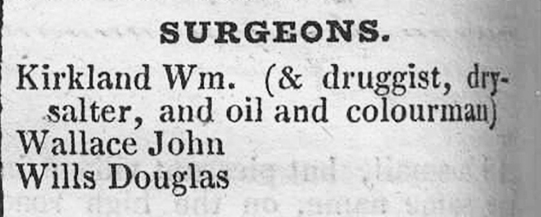

From Pigot's Directory of Ayrshire 1825-1826 for Old Cumnock
Some interesting newspaper clipping regarding Cumnock and the flag.

Northern Star and Leeds General Advertiser – Saturday 17 October 1840
CHARTIST INTELLIGENCE
CUMNOCK
… Monday the 5th inst., being the appointed day of (the Chartist) meeting all were anxious to catch a glance of the patriots as they came off the Glasgow coach. About one o clock the friends began to assemble from the various places. Having been marshalled in order by Mr John King the procession moved away to Auchinleck – there they met the friends from Mauchline and returned to Cumnock, marched through the principal places and finally took up station in the public square – the speakers and the committee occupying the steps of the village cross. As to the numbers present it is very difficult to make a calculation but it may suffice to say that it was the largest procession and meeting ever held here, with the exception of one or two at the passing of the Reform Act. A great many banners were carried in the following order: - First the old Covenanters’ Flag of Cumnock, born by our forefathers in the wars of the Covenant. Second the Union flag. Third the Republican flag. Fourth the Quarriers flag. Fifth the Shoemakers flag, the whole being headed by the Cumnock Band….

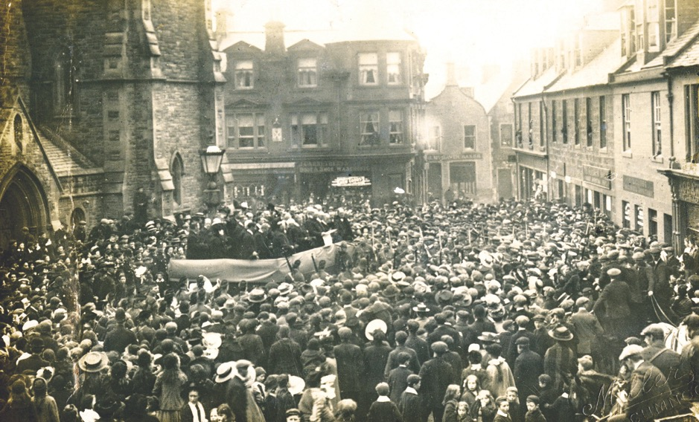

Although from a later date the scene above would have been very similar to the Chartist meeting of 1840.

Edinburgh Evening News - Wednesday 31 October 1888
Dundee Evening Telegraph - Wednesday 31 October 1888

RUMOURED SALE OF A COVENANTING FLAG
The Cumnock people have received a rude shock on hearing the report that the local Covenanter’s flag, at present in the Bishop’s Castle at the Glasgow Exhibition, has been sold by its possessor, Mr Dugald McGeachin, shoemaker, Cumnock for £50. It seems to be the prevalent notion that the flag really belongs to the town, and not to the keeper of it. “This,” writes Mr A B Todd, “certainly was the light in which Mr McGeachin’s father looked upon himself – the ‘keeper’ only of the banner;” and this seems to be confirmed by a poem on the flag written by the late Rev James Murray, parish minister of Cumnock, nearly thirty years ago. – Christian Leader.
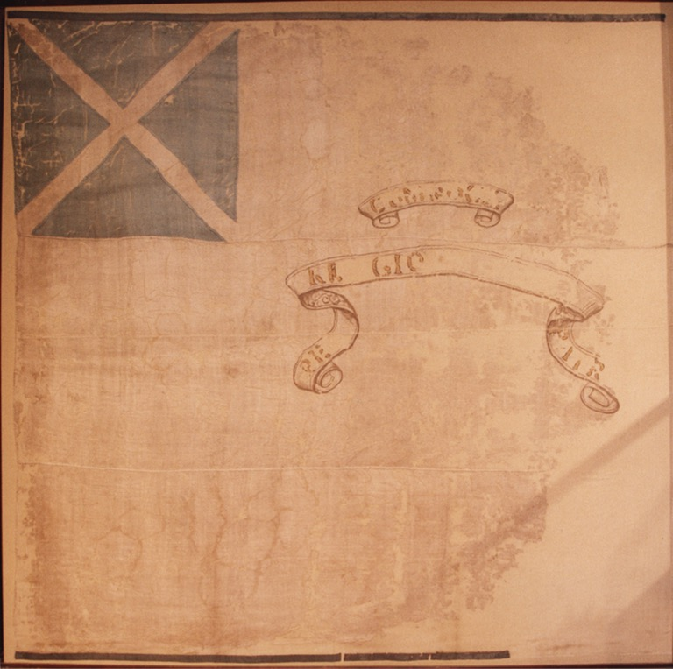

The Baird flag after restoration in 1979.
Songs of the Covenant Times by Rev James Murray of Cumnock.
Published in 1861 by William Nimmo Edinburgh and Duncan Ballantine Cumnock.

In this book there is note on ‘The Rescue at Bellopath, Auchinleck’ and a poem ‘The Banner of the Covenant’ which I have transcribed here:

Page 141
THE RESCUE AT BELLOPATH, AUCHINLECK.
This event occurred, according to Wodrow, about the 20th of June 1688. The person rescued was the Rev. Mr Houston. The soldiers who had charge of him passed the night previous to the rescue, at an inn in Cumnock called the Blue Tower. It still stands, in a state of good repair, in a back lane, which was then the principal street of the village. Early in the morning of the day of rescue a boy, employed for the purpose, carried intelligence of the troopers' movements to the ambuscade. That boy, when he grew up, married late in life; and his grandson, Mr Arthur, farmer, Wellhill, in the parish of New Cumnock, is still alive. The particulars embraced in the versified narrative were obligingly communicated to the author by Mr Hugh McGeachin, Cumnock, a descendant of the family of John McGeachin, who died of "the wound he received at Bellopath. Wodrow says McGeachin was a singularly pious man." There were others of the Covenanting party who were wounded; but he, alone, mortally

Pages 187-189
THE BANNER OF THE COVENANT.
KEPT BY MR HUGH McGEACHIN, CUMNOCK.

I.
In a quaint old-fashioned lane,
Running, zig-zag, here and there,
In his cottage neat and plain,
In his ample elbow-chair,
In his honest crusty manner,
Sits the keeper of the banner.

II.
Bring the ancient relic forth!
Precious 'tis, though old and tattered,
It has waved o'er men of worth,
When around it death was scattered;
It has glanced through moss and fen
Guarded by the Covenant men!
III.
Spread it out with tender care;
Slowly smooth its crumpled creases;
Use it gently, softly - there!
We've arranged its fragile pieces,
And its legend fitly scanned,
"For our God and Fatherland!"
IV.
Hearts have throbbed with hopes and fears,
When the rustling breeze thee fluttered;
Loving looks bedimmed with tears,
Long-drawn sighs and blessings muttered -
All have greeted thee of old,
On occasions manifold!
V.
When a tyrant ruled the land,
And our sires in deserts wandered;
When a sore afflicted band,
In despair unfurled the standard,
In the desperate fight and sally
Thou didst lure the faint to rally.
VI.
Old and tattered as thou art;
Little heeded, little known,
Thou didst play a valiant part
In the struggle long bygone;
And our boasted liberty,
Partly purchased was by thee.

VII.
Far be days with passion rife,
Wherein blood and gold are squandered;
May'st thou ne'er in civil strife,
Gleam again, time-honoured standard!
But, with peaceful fingers prest,
'Mid thy cob-webs lie at rest!

VIII.
Lie at rest, but should our soil
Menaced be with profanation,
Let the doughty sons of toil,
Worthy of their sires and station -
Worthy all of free men's glory,
Rally 'round their standard hoary!
IX.
Lie at rest; but yet when times -
Peaceful times of joyous greeting,
Wake the happy village chimes –
Rich and poor together meeting –
Let our brave old flag's display
Cheer the fleeting holiday!

So we know in 1861 that Hugh McGeachin was reputedly related to John McGeaghan who was injured at Bellowpath and died at Stonepark in 1688 and that Hugh was the keeper on the Covenanter’s Banner.

The McGeachins
The family have a long history in Cumnock. The furthest back I can trace is a Hugh McGeachin 1722-1807 possibly the great great grandson of John McGeachan 1640-1688, the Covenanter.

The Hugh we are interested in was born on 15 April 1794 in Old Cumnock, his father, Hugh was a Shoemaker and married Agnes Pirrie in Cumnock in 1791. He married Sarah Wyllie on 1 June 1821 in Cumnock. They had ten children. He died on 31 May 1873 in Cumnock. This Hugh was the reputed ‘keeper’ of the Cumnock flag and his son Donald or Dugald was the one who supposedly sold it for £50. Dugald was born in Cumnock in 1831, worked as a Shoemaker and married Margaret White in1858 and died in 1901 in Townhead Street, Cumnock. So what was the flag he was selling? It must have been the one that is kept at the Baird Institute in Cumnock as the flag in the Hunterian Museum was donated around 1819 by a Miss Mary Logan who, as said, we know nothing about. This flag was donated to the Baird in 1925 and we are hoping to find out who donated it.

This clipping from the Cumnock Chronicle dated 1979 gives an insight into the work done on the Baird Banner. The flag was in a very delicate condition and some conservation work was carried out on it in 1979. The silk was washed and straightened and the flag was sewn onto hardboard covered with cotton flannelette and heavy cotton. All the fabrics and threads used in the work were dyed to match the originals.

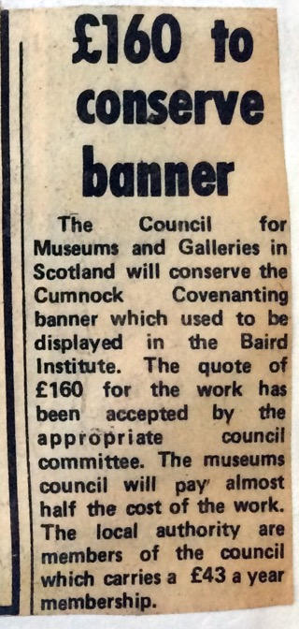

More to come as the research grows!

Read about John Warrick here: http://www.cumnockhistorygroup.org/people-historians.html
Hunterian catalogue: http://collections.gla.ac.uk/ - view=list&id=3af3&what=Covenanters%20banner
Future Museums entry: https://shar.es/1U6hKx
Read about Adam Brown Todd here: http://www.cumnockhistorygroup.org/people-writers.html
More about the Chartist movement here: https://en.wikipedia.org/wiki/Chartism
Catalogue. Page 90 item no 382 and index page 267. D McGeachin 12 Glaisnock Street, Cumnock. https://archive.org/stream/bookofbishopscas00glas - pge/90/mode/2up/search/cumnock
Book here: https://babel.hathitrust.org/cgi/pt?id=njp.32101068155272;view=2up;seq=1;size=125
James Murray was the 5th minister to serve the congregation of the Established Church, the Square, Cumnock. He served from 1843-1875. You can find out more about him here: http://www.cumnockhistorygroup.org/people-clergy.html
Duncan McLean Ballantine (1829-1877) was a printer in Cumnock. In 1861 he was living at 12 Glaisnock Street, Cumnock as a Printer, Book Seller & Stationer. His family later took over the Cumnock Chronicle.
Mr Arthur died March 1860.
Hugh McGeachin 1794-1873. In the 1861 Census he I living at Long Causewayside, Old Cumnock. Profession Shoemaker.
John McGeachin, the farmer in Meikle Auchingibbert, was wounded in a skirmish with dragoons on the 20th June 1688 at Bellow Path near Lugar while taking part in the rescue of the Rev David Houston. He died of his wounds three weeks later and was buried at this spot. The inscription on his gravestone reads: 'Here lies John McGeachan, who for his constant adherence to the word of God, prosecuting the ends of our National League and Covenant, and appearing for the rescue of the Rev David Houston one of the prosecuted ministers of the gospel was shot at Bellow Path by a party of bloody dragoons xxviii July 1688. Erected Anno 1728." Warrick states that the date is in error, and a fresh stone was erected in 1836, with the amendment, but miss-spelt the name as "MacGeachan". Both stones are enclosed by an iron railing. J Warrick 1899; OS Name Book 1855; 1959 As described, except that an inscription on the later stone states it was erected in 1856, not 1836. The turf-covered footings of an old croft lie a little to the N of the burial site at NS 5925 1950.

